Priority Queue:

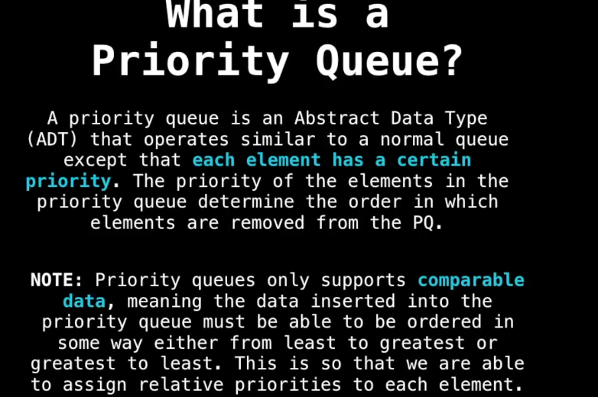

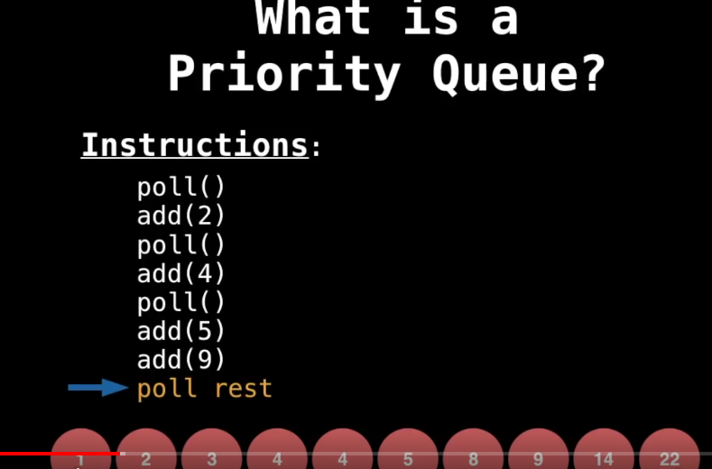

When we poll() we get number in sequence. Priority Queue uses heap to identify least number to poll().

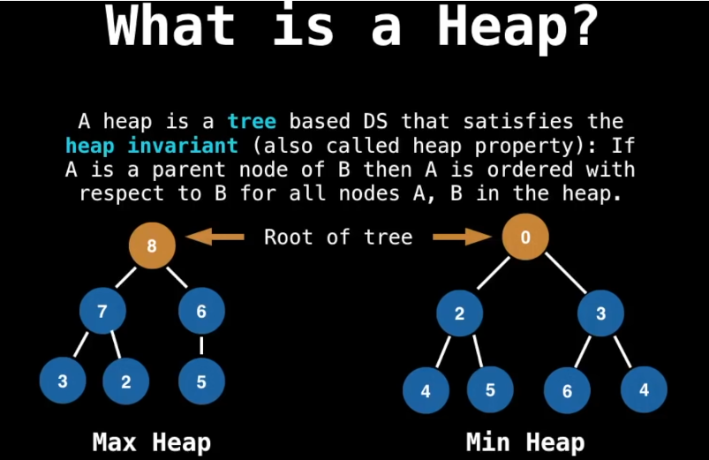

Heap must be binomial tree and must be max heap for min heap.

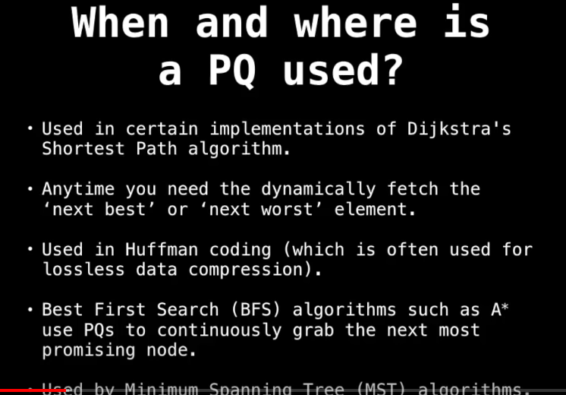

String comparison is done on the bases of the lexicographical(Lex) order. nLex is reverse order.

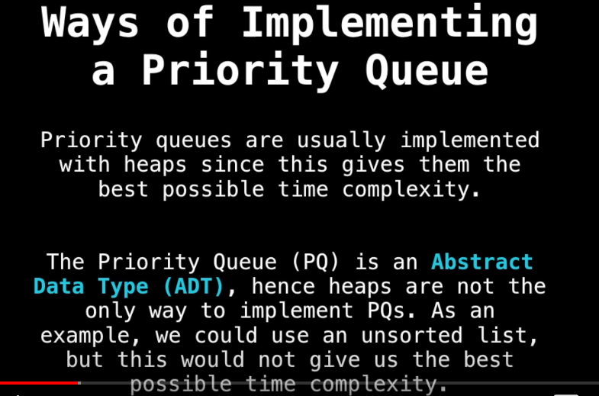

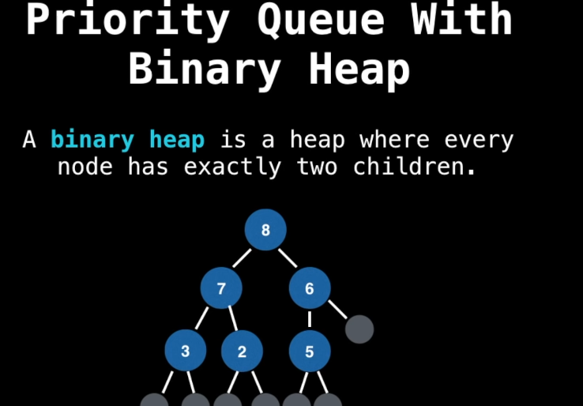

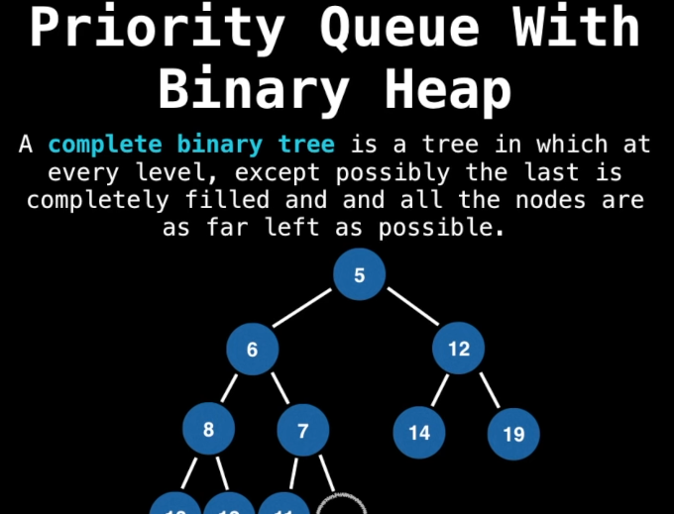

Add(): Adding the node to tree will always insert at the bottom of the tree and heapify the tree.

Poll(): Deleting the root node and the then swap root with last node and heapify the tree.

Remove(): Make liner search on tree to find the node and delete node and swap node with last node and heapify the tree.

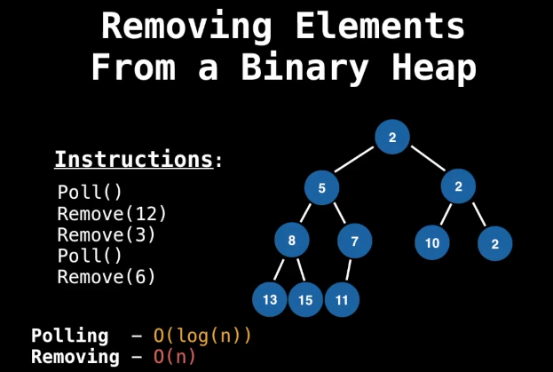

How to improve the O(log(n))? Using the HashTable to keep track index.

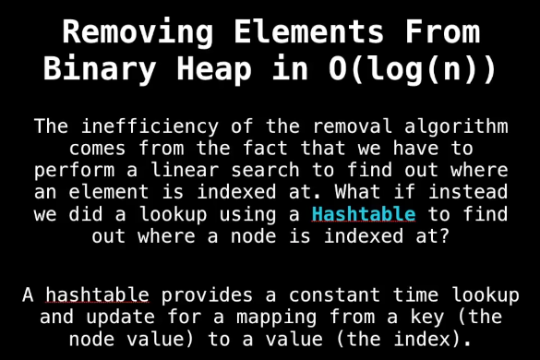

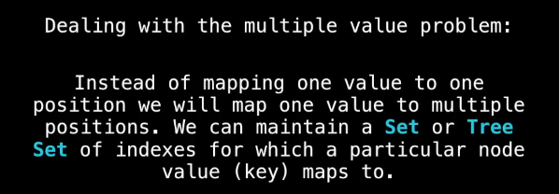

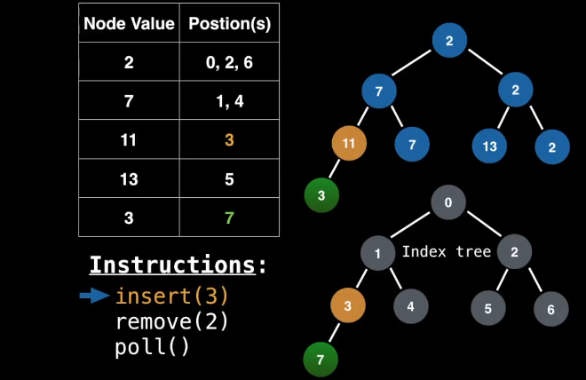

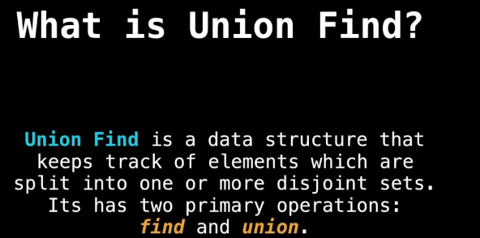

Union Find application is used in Kruskal’s minimum spanning tree.

HASH TABLE(HT)

It is data structure that provides a mapping from keys to values using technique called hashing. We store as key-value pares and key must be hashable . we demand that keys used in our hash table are immutable data type.

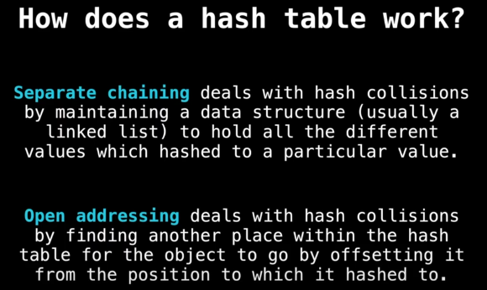

Openaddressing(Linerprobing):

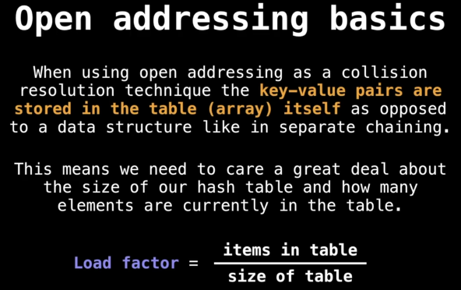

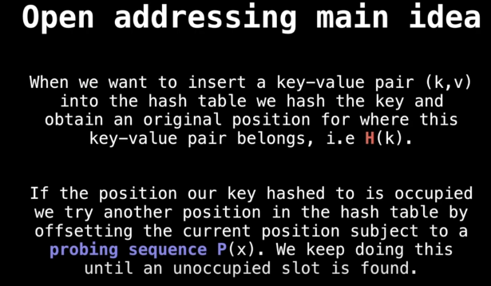

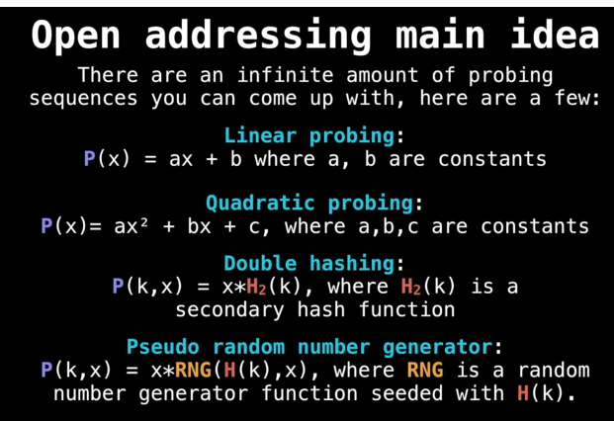

FenWick Tree:

